A Project Report On

COSMETIC INSIGHTS

1. **Introduction**
   1. Project Overview

The Project titled “Cosmetic Insights” aims to analyze various skincare and cosmetic brands using Tableau. The dataset includes Product Name, Rating, Skin Type Suitability, Price Range and Brand Performance. The goal is to help consumers choose suitable products based on skin type and brand quality.

* 1. Purpose

The purpose of this project is to uncover patterns in cosmetic product is to uncover patterns in cosmetic product offerings, understand consumer preferences, and offer recommendations through interactive visualizations.

1. **Ideation Phase**
   1. Problem Statement

Consumers often find it challenging to select appropriate skincare products due to a lack of comparative insights based on skin suitability and product effectiveness.

* 1. 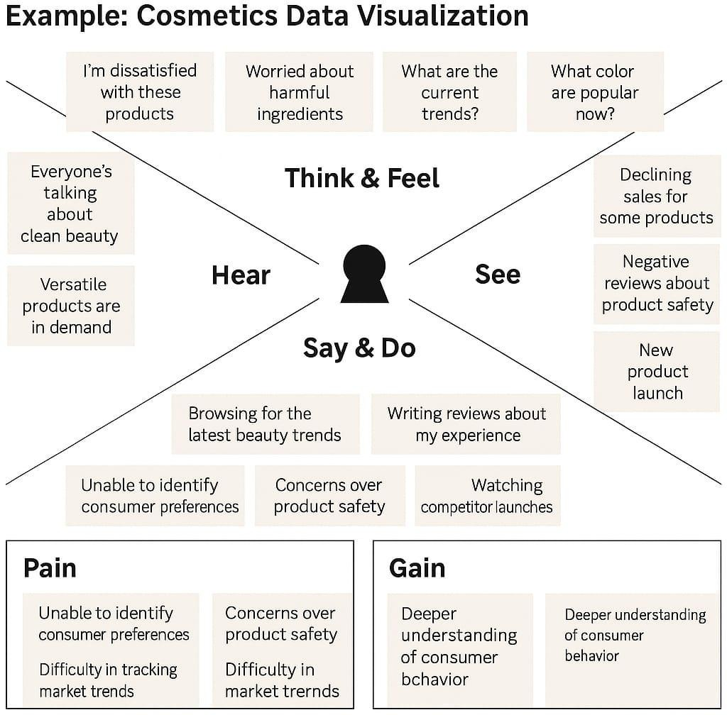 Empathy Map Canvas
  2. Brainstorming

Brainstorming provides a free and open environment that encourages everyone within a team to participate in the creative thinking process that leads to problem solving. Prioritizing volume over value, out-of-the-box ideas are welcome and built upon, and all participants are encouraged to collaborate, helping each other develop a rich amount of creative solutions.

Step-1: Team Gathering, Collaboration and Select the Problem Statement

Step-2: Brainstorm, Idea Listing and Grouping

Step-3: Idea Prioritization

**3.Requirement Analysis**

3.1 Customer Journey Map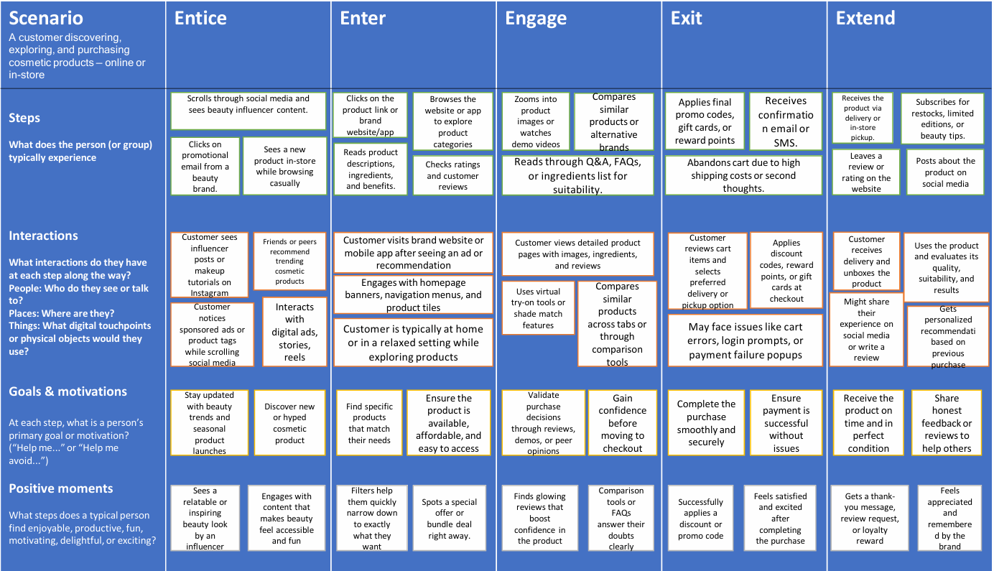

3.2 Solution Requirement

Functional Requirements:

|  |  |  |
| --- | --- | --- |
| **FR No.** | **Functional Requirement (Epic)** | **Sub Requirement (Story / Sub-Task)** |
| FR-1 | Sales Dashboard | View Total Sales, Revenue & Profit Filter by Product Category & City |
| |  | | --- | | FR-2 |  |  | | --- | |  | | |  | | --- | | Customer Insights |  |  | | --- | |  | | View Customer Preferences Highlight Top Products by Gender & Age Group |
| FR-3 | Trend Analysis | Show Monthly & Seasonal Trends Display Line/Area Charts by Product Type |
| FR-4 | Text Analytics | Generate Word Cloud from Tags/Reviews Filter Keywords by Category |
| FR-5 | Funnel Analysis | Visualize Customer Journey Stages Track Drop-offs at Each Stage |

Non-functional Requirements:

|  |  |  |
| --- | --- | --- |
| **FR No.** | **Non-Functional Requirement** | **Description** |
| NFR-1 | Usability | The system should be easy to use and navigate, even for first-time users, with a user-friendly interface. |
| |  | | --- | | NFR-2 |  |  | | --- | |  | | Security | The system must ensure data confidentiality, integrity, and access control to prevent unauthorized access. |
| |  | | --- | | NFR-3 |  |  | | --- | |  | | Reliability | The system should operate consistently without failures and recover gracefully from unexpected issues. |
| |  | | --- | | NFR-4 |  |  | | --- | |  | | Performance | The system should provide quick response times and handle high volumes of data and user interactions efficiently |
| |  | | --- | | NFR-5 |  |  | | --- | |  | | Availability | The system should be accessible and operational 24/7 with minimal downtime. |

3.3 Data Flow Diagram

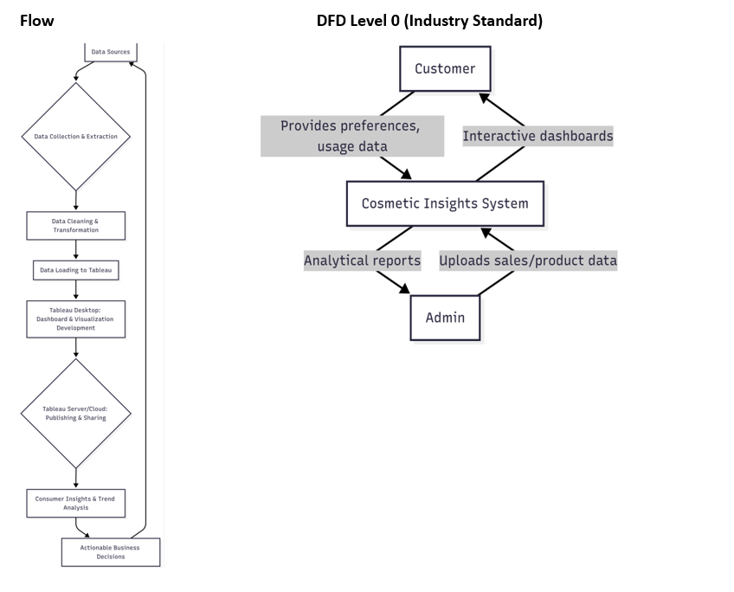

3.4 Technology Stack

|  |  |  |  |
| --- | --- | --- | --- |
| **S.No** | **Component** | **Description** | **Technology** |
| 1 | User Interface | How user interacts with application e.g., Web UI, Mobile App, Chatbot | HTML, CSS, JavaScript / AngularJS / ReactJS etc |
| 2 | Application Logic-1 | Logic for a process in the application | Java / Python |
| 3 | Application Logic-2 | Logic for a process in the application | IBM Watson STT service |
| 4 | Application Logic-3 | Logic for a process in the application | IBM Watson Assistant |
| 5 | Database | Data Type, Configurations etc. | MySQL, NoSQL, etc |
| 6 | Cloud Database | Database Service on Cloud | IBM DB2, IBM Cloudant etc. |
| 7 | File Storage | File storage requirements | IBM Block Storage or Other Storage Services |
| 8 | API Gateway | Manages and routes API calls between client and backend | IBM API Connect, AWS API Gateway, Postman |
| 9 | Authentication Service | Handles login, registration, and access control | Firebase Auth, OAuth 2.0, JWT, IBM App ID |
| 10 | Notification Service | Sends alerts/notifications to users | Firebase Cloud Messaging, Twilio, SendGrid, IBM Push Notifications |

**Table-2: Application Characteristics:**

|  |  |  |  |
| --- | --- | --- | --- |
| **S.No** | **Characteristics** | **Description** | **Technology** |
| 1 | Data Ingestion & Storage | How raw cosmetic data (e.g., product reviews, ingredient lists, social media trends, sales data) is collected, processed, and stored efficiently for analysis | e.g., Apache Kafka, AWS S3, Google Cloud Storage, PostgreSQL, MongoDB, Snowflake, Databricks |
| 2 | Data Processing & ETL | The methods and tools used for cleaning, transforming, and loading raw data into a format suitable for analysis and model training. | e.g., Apache Spark, Pandas, SQL, AWS Glue, Google Dataflow, Azure Data Factory |
| 3 | Machine Learning Models | The types of AI/ML models employed for tasks like sentiment analysis, trend prediction, product recommendation, image recognition (for product attributes), or ingredient analysis. Justify model choices. | e.g., TensorFlow, PyTorch, Scikit-learn, XGBoost, Hugging Face Transformers, AWS SageMaker, Google AI Platform |
| 4 | Scalable Analytics | Justify the scalability of the analytics infrastructure to handle growing datasets and increasing query loads for real-time or batch insights. | e.g., Distributed computing frameworks (Spark), Cloud-native analytics services (BigQuery, Redshift) |
| 5 | API & Integration | How the cosmetic insights are exposed to other applications or front-end interfaces, including data retrieval and model inference endpoints. | e.g., REST APIs, GraphQL, FastAPI, Django REST Framework, Flask, AWS API Gateway, Google Cloud Endpoints |

**4.Project Design**

4.1 Problem Solution Fit

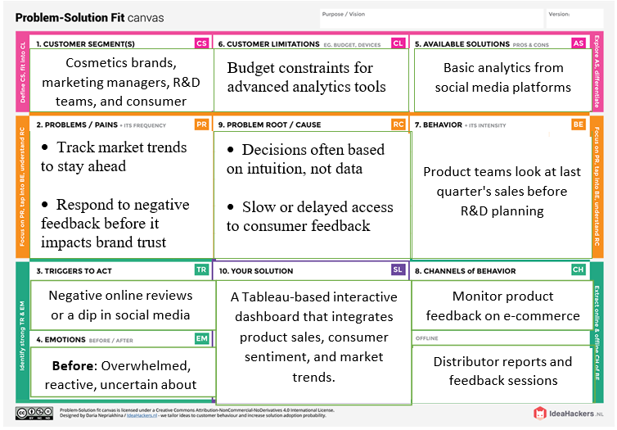

4.2 Proposed Solution

|  |  |  |
| --- | --- | --- |
| **S.No** | **Parameter** | **Description** |
| 1 | Problem Statement (Problem to be solved) | Cosmetics companies lack a  centralized, real-time platform to analyze consumer  preferences, product  performance, and market trends, leading to delayed decisions and missed  opportunities. |
| 2 | Idea / Solution description | Cosmetic Insights is a Tableau- powered dashboard solution  that provides interactive, real- time analytics on customer  behavior, product feedback, and industry trends, helping businesses make informed decisions. |
| 3 | Novelty / Uniqueness | Unlike traditional BI tools, this solution combines consumer sentiment, product sales, and predictive analysis into a single visualization platform tailored specifically for the cosmetics  industry. |
| 4 | Social Impact / Customer Satisfaction | By understanding and responding to consumer  preferences swiftly, brands can improve product offerings, address safety concerns early, and enhance customer satisfaction and trust. |
| 5 | Business Model (Revenue Model) | Subscription-based model for cosmetics companies, offering tiered pricing based on data  volume, dashboard features. |

4.3 Solution Architecture

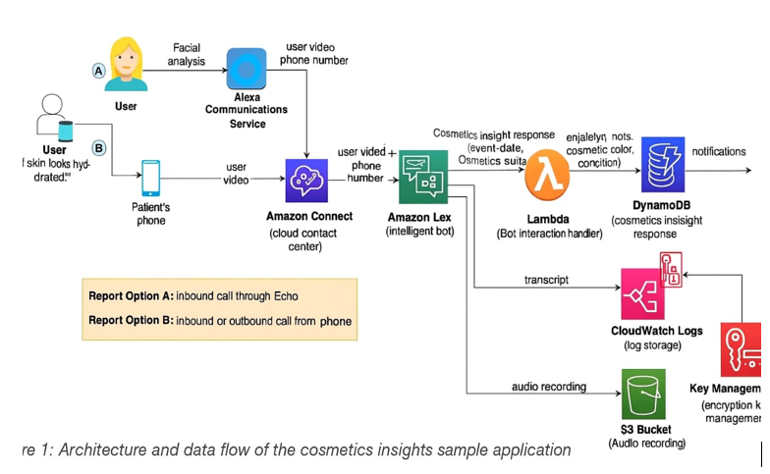

**5. Project Planning & Scheduling**

5.1 Project Planning

|  |  |  |  |  |  |  |
| --- | --- | --- | --- | --- | --- | --- |
| **Sprint** | **Functional Requirement (Epic)** | **User Story Number** | **User Story / Task** | **Story Points** | **Priority** | **Team Members** |
| US01 | The system shall import and preprocess cosmetics data | US01 | As a data analyst, I want to clean and preprocess cosmetics sales data | 5 | High | Hima Sri N,   Gajula Anjani,  Daram Lowkya,   Garre Vagdevi |
| US02 | The system shall allow users to visualize consumer preferences | US02 | As a dashboard user, I want to filter sales data by city, product, and date | 8 | High | Hima Sri N,   Gajula Anjani,  Daram Lowkya,   Garre Vagdevi |
| US03 | The dashboard shall display product-wise and category-wise sales performance over selected time periods. | US03 | As a marketer, I want to view consumer preferences in a word cloud | 5 | Medium | Hima Sri N,   Gajula Anjani,  Daram Lowkya,   Garre Vagdevi |
| US04 | The system shall identify and highlight negative feedback trends using charts and sentiment-based indicators. | US04 | As a QA lead, I want to identify spikes in negative product reviews | 8 | High | Hima Sri N,   Gajula Anjani,  Daram Lowkya,   Garre Vagdevi |
| US05 | The dashboard shall provide interactive visualizations | US05 | As a strategist, I want to analyze product success trends using forecasts | 8 | Medium | Hima Sri N,   Gajula Anjani,  Daram Lowkya,   Garre Vagdevi |

**Project Tracker, Velocity & Burndown Chart: (4 Marks)**

|  |  |  |  |  |  |  |
| --- | --- | --- | --- | --- | --- | --- |
| **Sprint** | **Total Story Points** | **Duration** | **Sprint Start Date** | **Sprint End Date (Planned)** | **Story Points Completed (as on Planned End Date)** | **Sprint Release Date (Actual)** |
| Sprint-1 | 6 | 2 days | 15-06-25 | 17-06-25 | 5 | 25-06-25 |
| Sprint-2 | 8 | 1 day | 17-06-25 | 18-06-25 | 5 | 25-06-25 |
| Sprint-3 | 10 | 3 days | 19-06-25 | 21-06-25 | 6 | 25-06-25 |
| Sprint-4 | 5 | 2 days | 23-06-25 | 25-06-25 | 5 | 25-06-25 |

**6.Functional and Performance Testing**

6.1 Performance Testing

|  |  |  |
| --- | --- | --- |
| **S.No** | **Parameter** | **Screenshot / Values** |
| 1 | Data Rendered | Used cosmetics.csv containing Label, Brand, Name, Price, Rank, Ingredients, Combination, Dry, Normal, Oily, Sensitive as Fields. |
| 2 | Data Preprocessing | Checked for Null values, Missing Values and ensured proper formatting for Tableau Ingestion. |
| 3 | Utilization of Filters | Filters used:  Rank, Brand, Name, Dry. |
| 4 | Calculation Fields Used | Used to derive suitability counts and average ranks.  Used Distinct count of Product Name. |
| 5 | Dashboard Design | Designed Dashboard with 9 Visualizations.  Dashboard1: Product Ranking & Detailed Analysis.    Dashboard2: Product Sustainability Overview. |
| 6 | Story Design | Designed Story with 6 story points. |

**7. Results**

Activity 1.1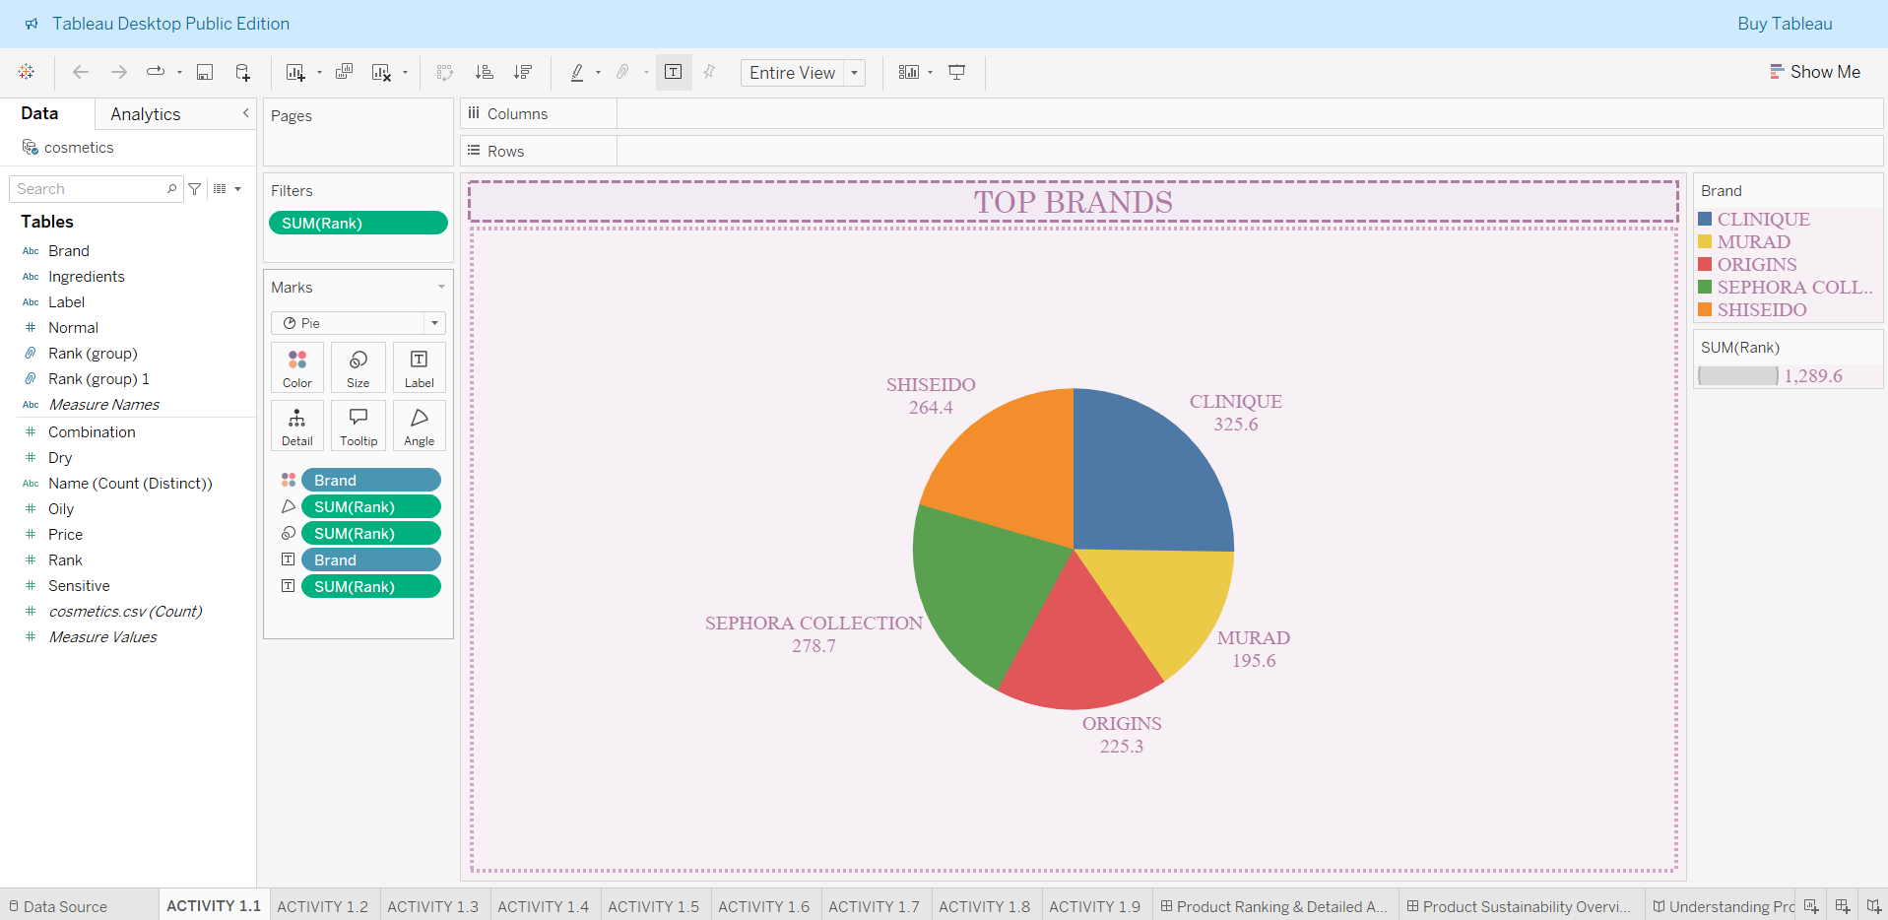

Activity 1.2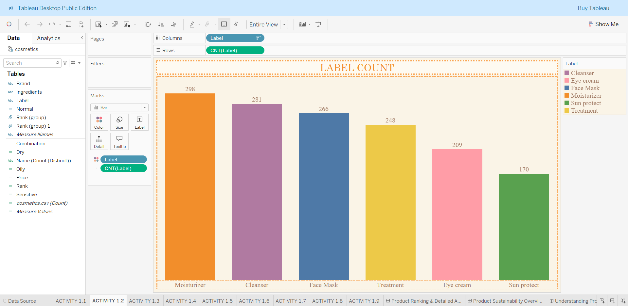

Activity 1.3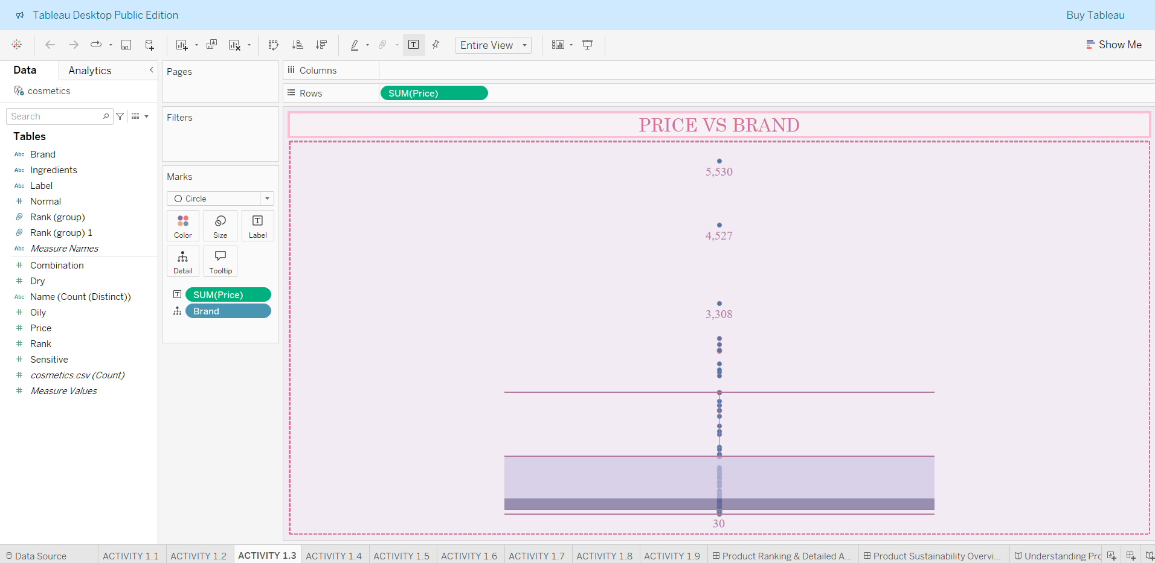

Activity 1.4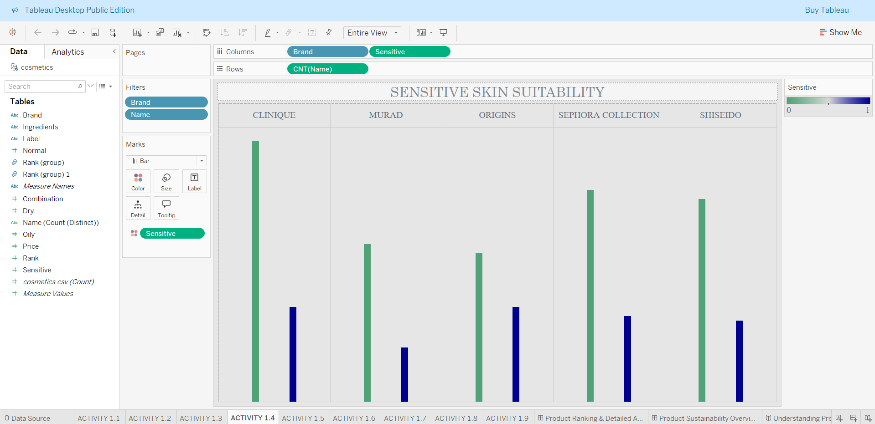

Activity 1.5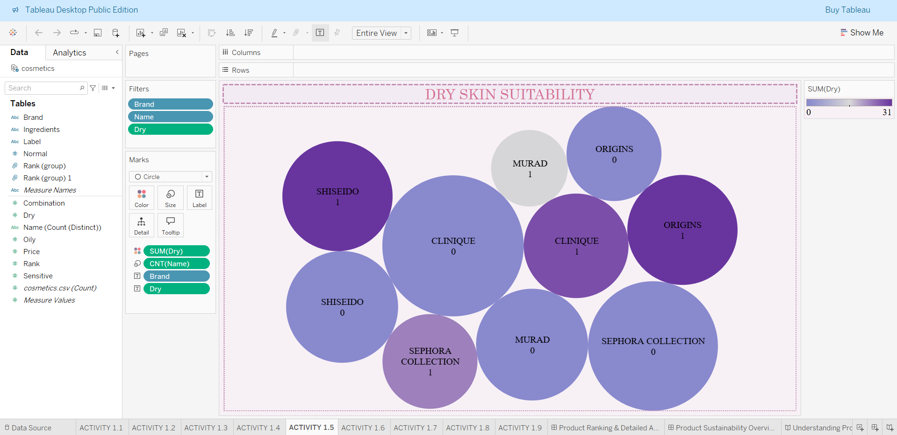

Activity 1.6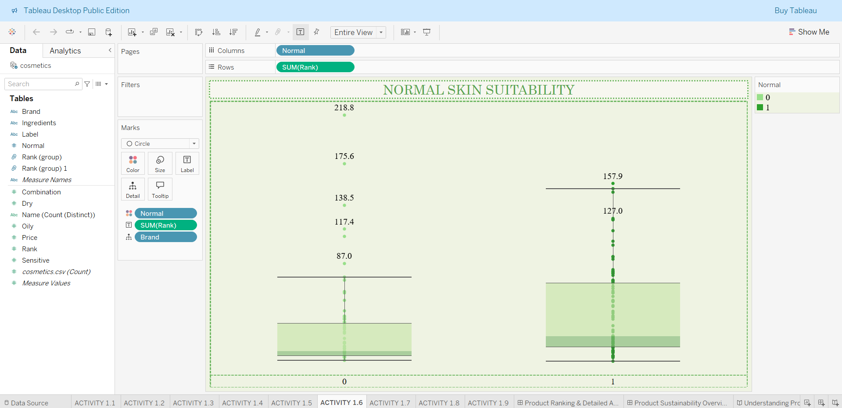

Activity 1.7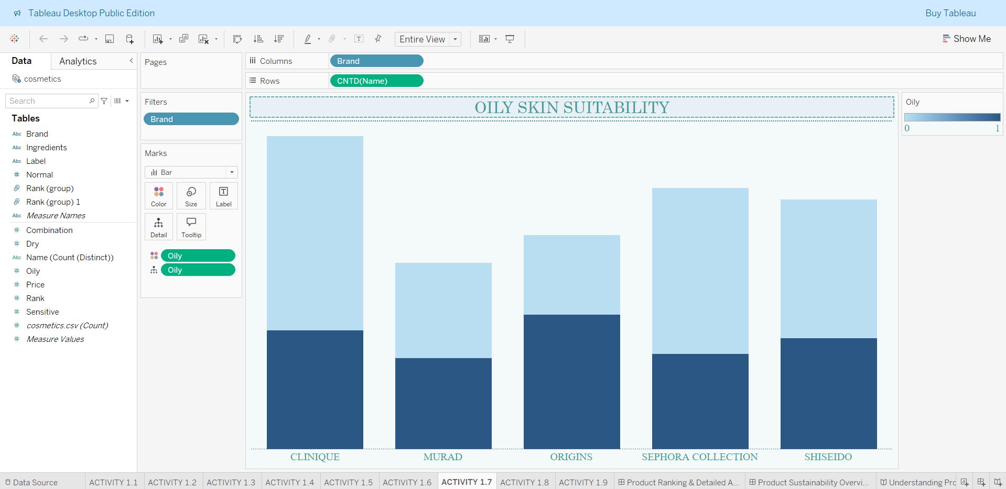

Activity 1.8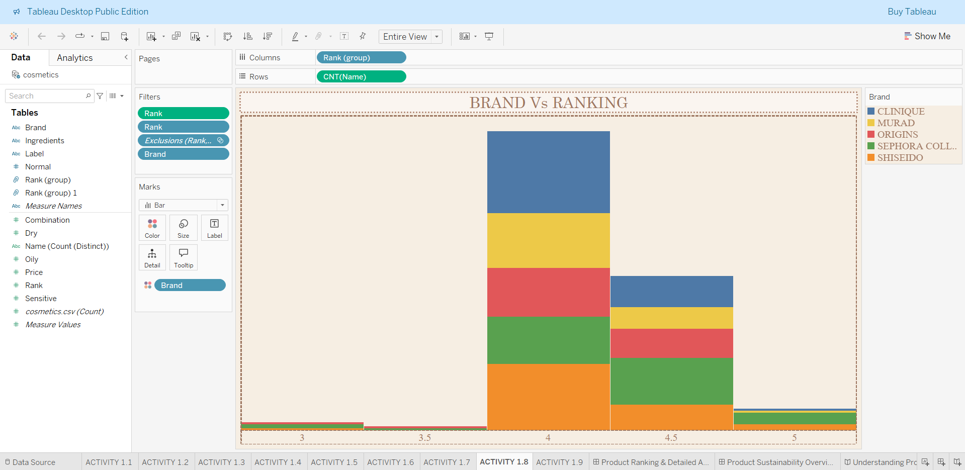

Activity 1.9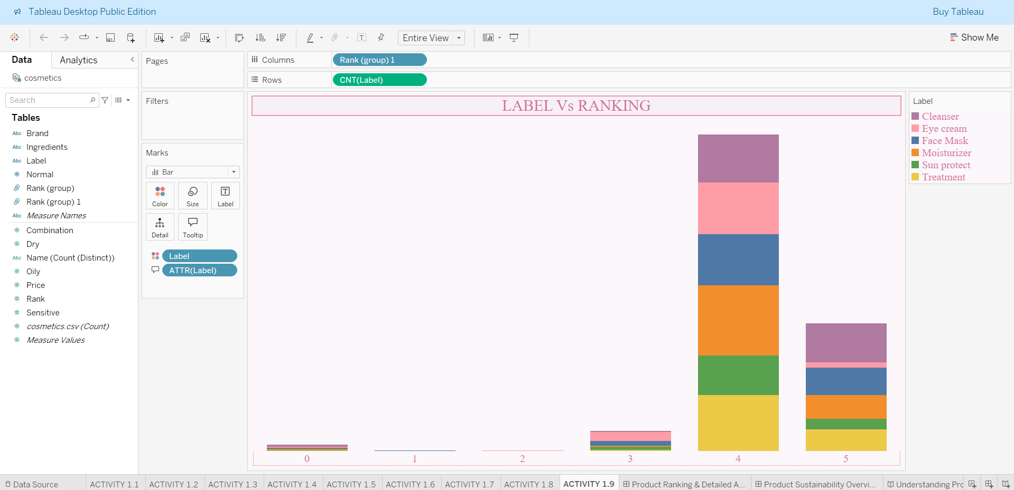

Dashboard 1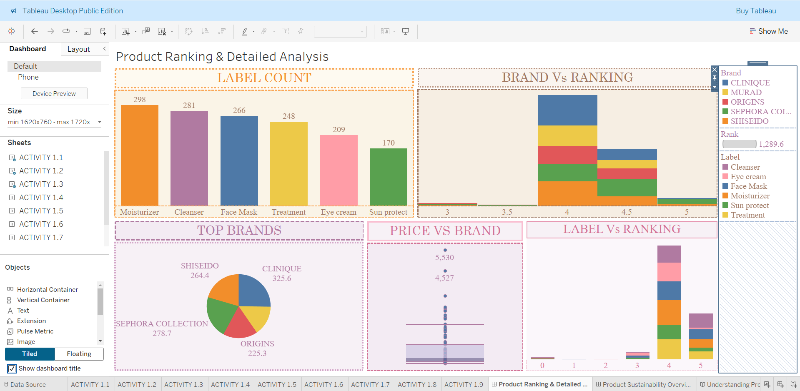

Dashboard 2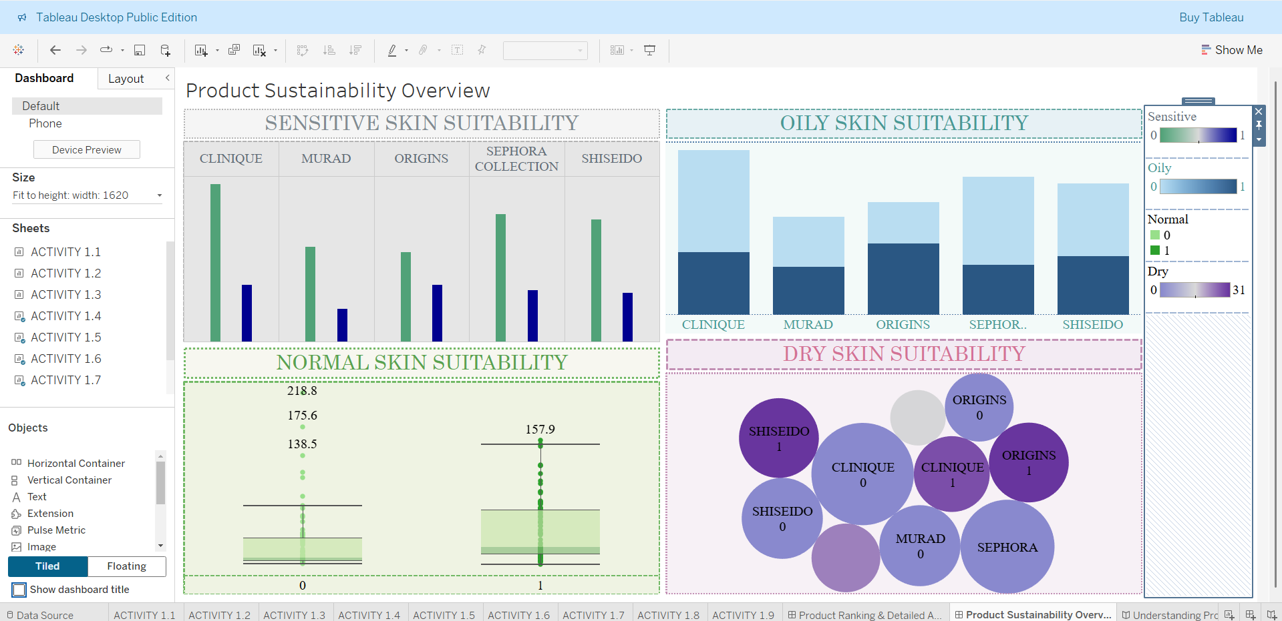

Story [6 Story Points]

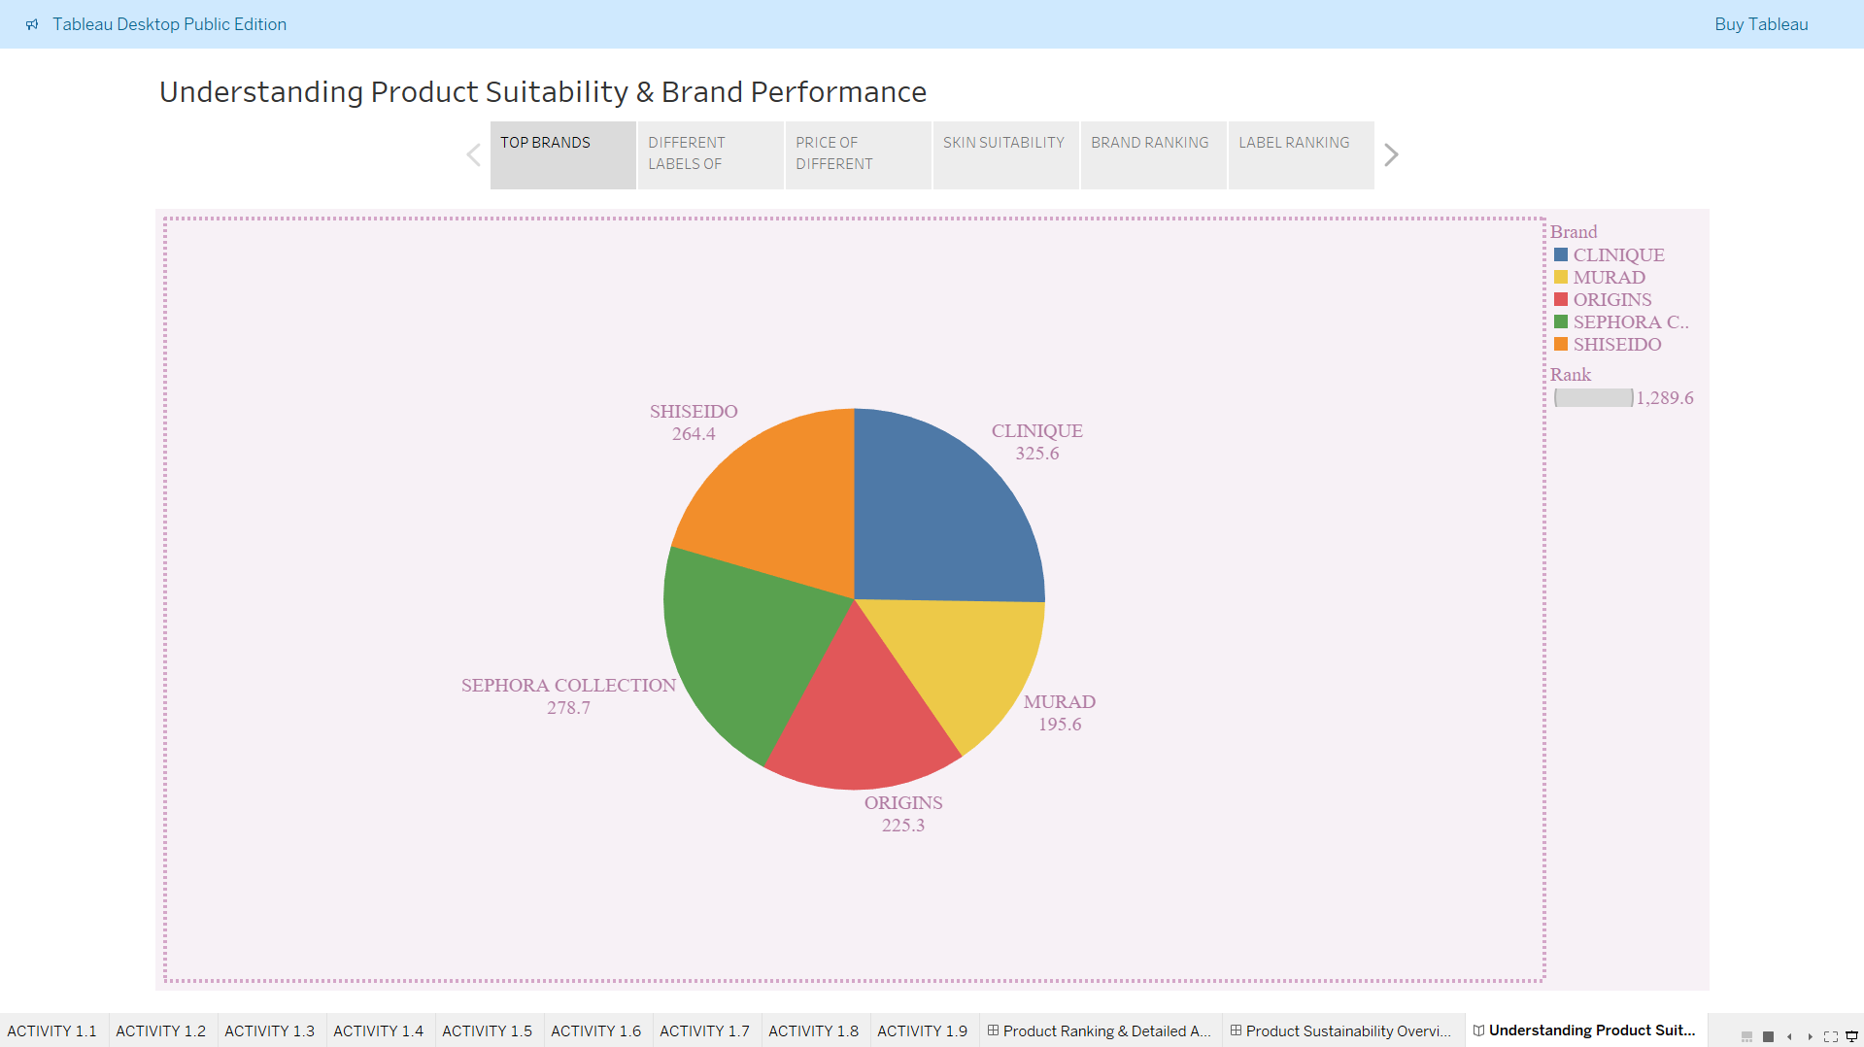

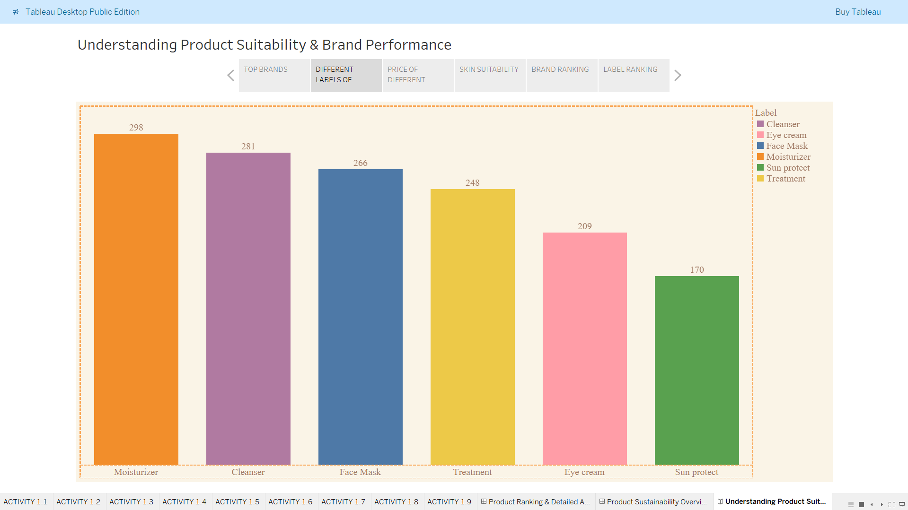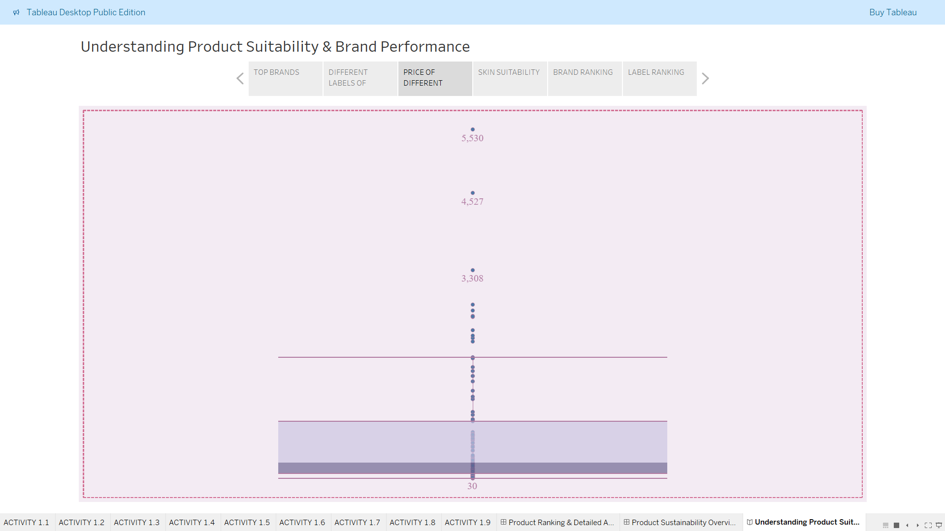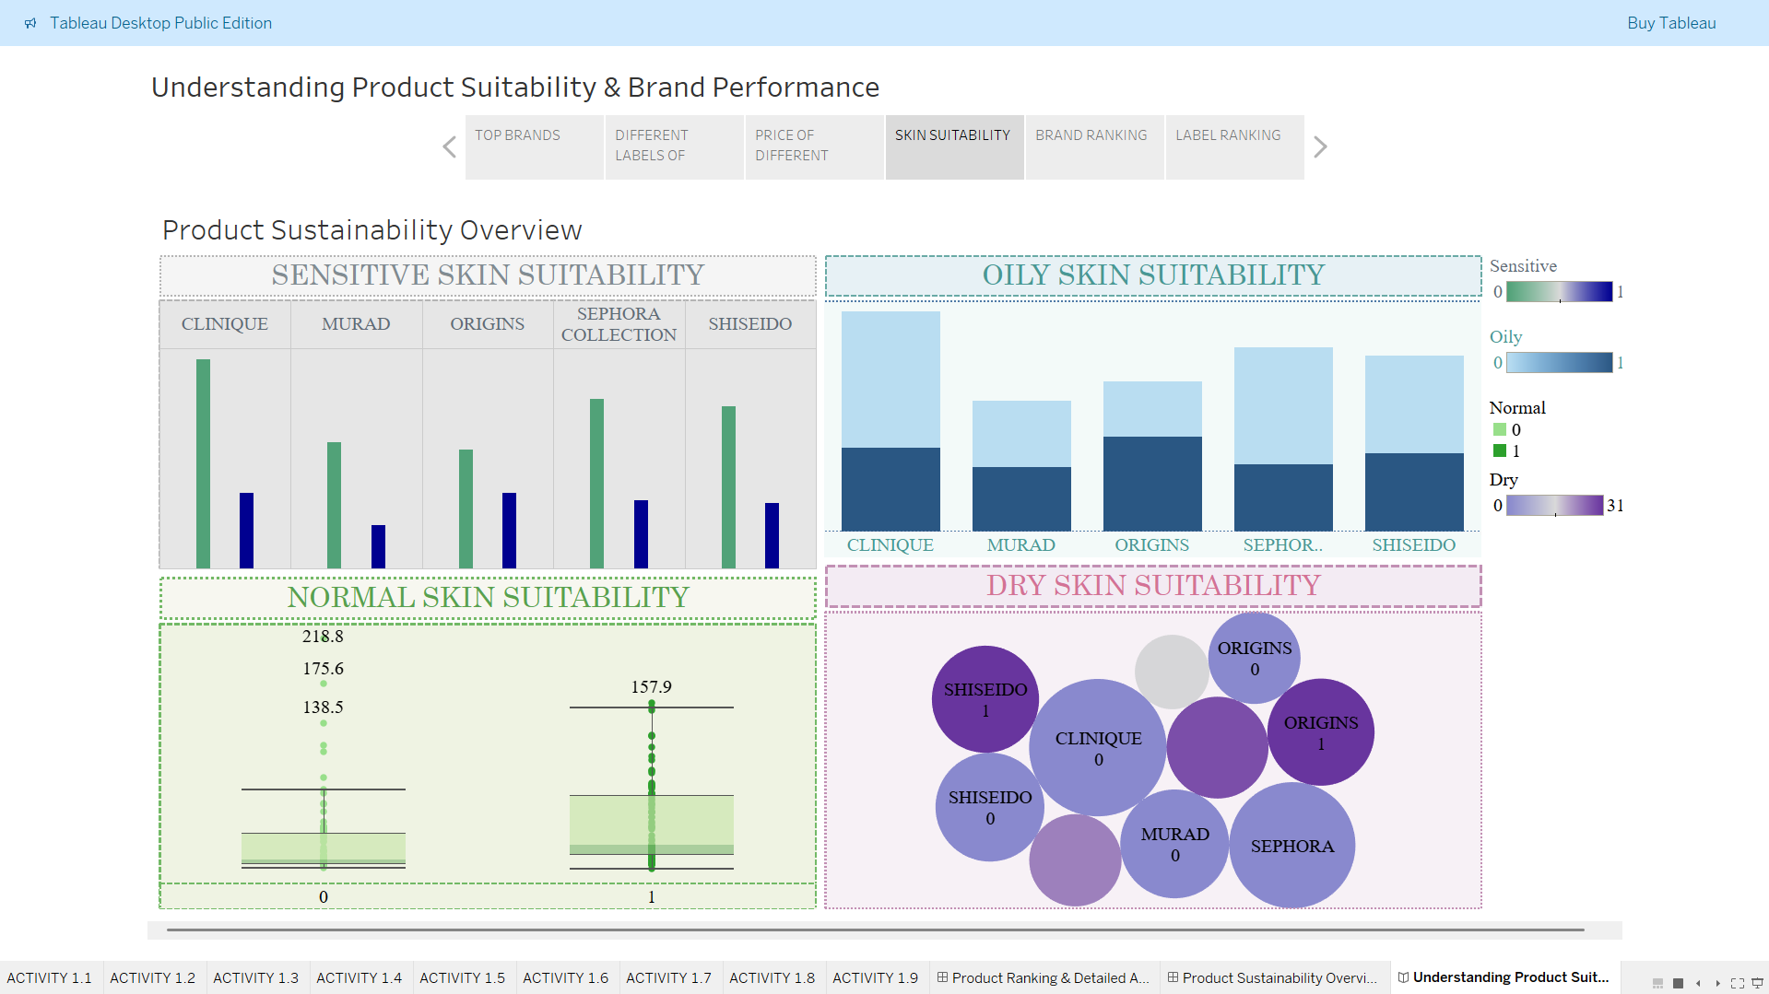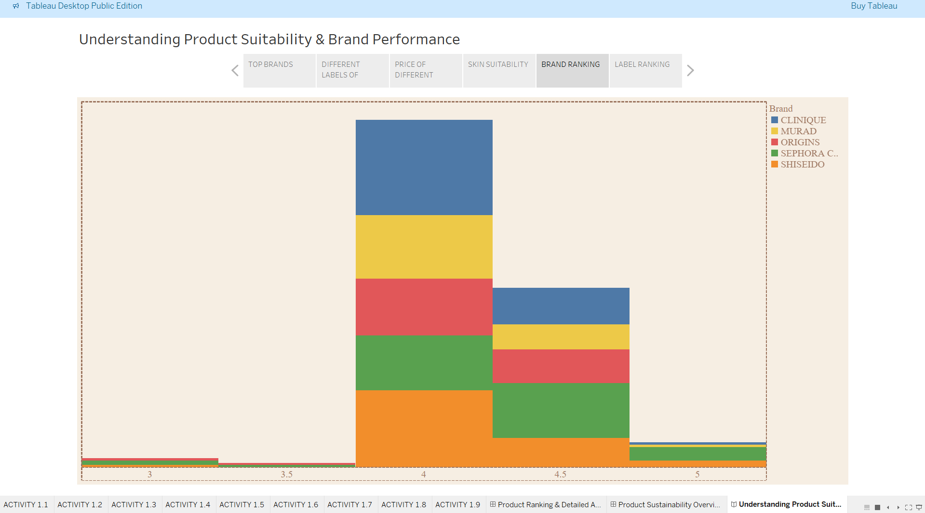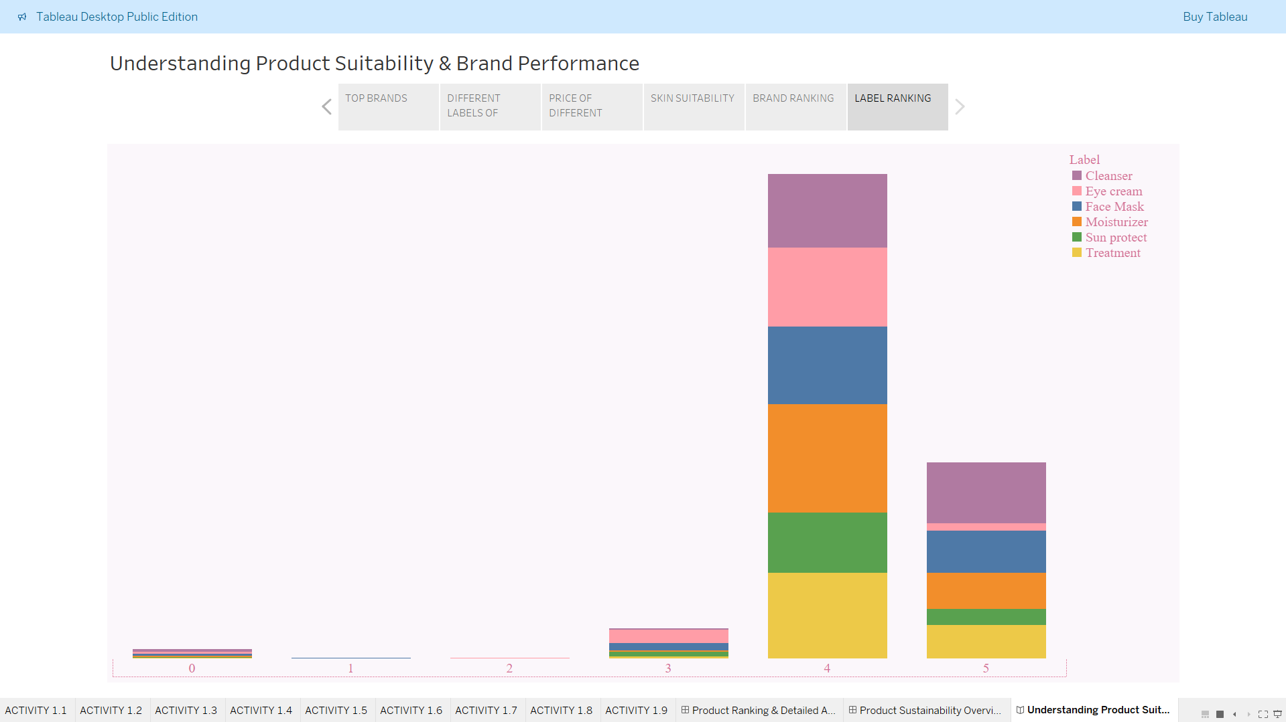

**8.ADVANTAGES & DISADVANTAGES**  
Advantages

* User-friendly interface
* Interactive and visually engaging
* Helps identify trends and consumer-friendly products

Disadvantages

* Limited to data available
* Doesn’t account for real-time customer reviews or ingredients

**9.CONCLUSION**  
This project demonstrates how Tableau can be used effectively to uncover insights in the cosmetic industry, guiding users towards better product decisions based on skin type and brand rankings.

**10.Future Scope**

* Include ingredient analysis for allergic reactions
* Add real-time user review tracking
* Expand dataset to include more brands and international markets